 | SIDDARTHA INSTITUTE OF SCIENCE AND TECHNOLOGY :: PUTTUR  (AUTONOMOUS)  Siddharth Nagar, Narayanavanam Road – 517583  QUESTION BANK (DESCRIPTIVE)  Subject Code :KOM (19ME0304) Course & Branch : B.Tech – ME  Year & Sem : II – B.Tech & I –Sem Regulation : R19
*********************************************************************************
UNIT – I
1. |  | Explain the classification of the kinematics pairs with neat sketch and all the aspect. | 10M
2. |  | Explain the inversions of double slider crank chain with neat sketch and list out the practical applications of inversions. | 10M
3. | a. | What is pantograph? Show that it generates a path similar to the path traced by a point on the mechanism. | 5M
 | b. | What is constrained motion and what are the different types of constrained motions? Give one example for each with suitable sketch. | 5M
4. |  | Explain the inversions of single slider crank chain with neat sketch and list out the practical applications of inversions? | 10M
5. |  | What are the practical applications of inversions of the 4 – bar linkage?  Explain all with neat sketch. | 10M
6. |  | What are the practical applications of inversions of the single slider crank chain? Explain all with neat sketch. | 10M
7. |  | What are the practical applications of inversions of the double slider crank chain? Explain all with neat sketch. | 10M
8. | a. | Define the Grashof’s law and identify the mechanism produced by the following linkage. | 5M
 | b. | Explain about the Kutzbach criterion and why it is used? Show the proof? | 5M
9. |  | Define the term ‘Degrees of Freedom’. And find the degrees of freedom for the following linkages.  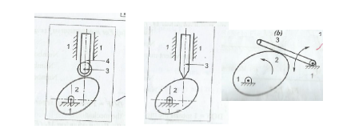 | 10M
10. | a. | Explain the working of beam engine with neat sketch | 5M
 | b. | Explain the working of Oscillating cylinder engine with neat sketch | 5M

UNIT – II
1. | a. | What is the condition for correct steering? Write fundamental equation of it. | 5M
 | b. | Give a neat sketch of the straight line motion Hart mechanism. | 5M
2. |  | With neat sketch, explain the Ackerman steering gear of an automobile. | 10M
3. |  | With neat sketch, explain the Davis steering gear of an automobile. | 10M
4. | a. | Sketch and explain the working of Grasshopper straight line mechanism | 5M
 | b. | Sketch and Describe the working of Peaucellier mechanism | 5M
5. |  | Sketch and Describe the Scott-Russell and Robert’s straight-line motion mechanisms. | 10M
6. | a. | Sketch and Describe the watt mechanism | 5M
 | b. | Sketch and Describe the Tchebichef mechanism | 5M
7. | a. | Differentiate between the Davis and Ackerman’s steering mechanism | 5M
 | b. | What are the disadvantages of Davis steering gear mechanism | 5M
8. |  | With neat sketch, explain the working of Universal joint. And write applications also. | 10M
9. |  | With neat sketch, explain the working of any two of approximate straight line mechanisms. | 10M
10 |  | With neat sketch, explain the working of any two of exact straight line  mechanisms | 10M

UNIT - III
1. |  |  |  | In a four bar chain ABCD, AD is fixed and is 150 mm long. The crank AB is 40 mm long and rotates at 120 r.p.m. clockwise, while the link CD = 80 mm oscillates about D. BC and AD are of equal length. Find the angular velocity of link CD when angle BAD = 60°. | 10M
2. |  |  |  | In Fig. 7.9, the angular velocity of the crank OA is 600 r.p.m. Determine the linear velocity of the slider D and the angular velocity of the link BD, when the crank is inclined at an angle of 75° to the vertical. The dimensions of various links are: OA = 28 mm; AB = 44 mm; BC 49 mm; and BD = 46 mm. The center distance between the centres of rotation O and C is 65 mm. The path of travel of the slider is 11 mm below the fixed point C. The slider moves along a horizontal path and OC is vertical  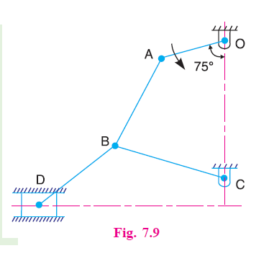 | 10M
3. |  |  |  | The dimensions of the mechanism, as shown in Fig. 7.30, are as follows: AB = 0.45 m; BD = 1.5 m: BC = CE = 0.9 m. The crank AB turns uniformly at 180 r.p.m. in the clockwise direction and the blocks at D and E are working in frictionless guides. Draw the velocity diagram for the mechanism and find the velocities of the sliders D and E in their guides. Also determine the turning moment at A if a force of 500 N acts on D in the direction of arrow X and a force of 750 N acts on E in the direction of arrow Y.  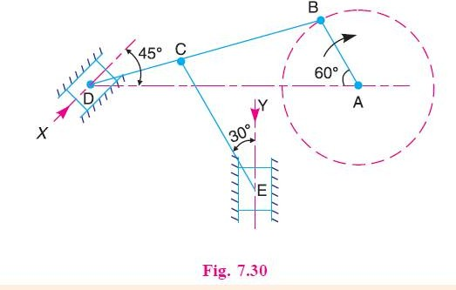 | 10M
4. | a. |  |  | Explain how the velocities of a slider and the connecting rod are obtained in a slider crank mechanism. | 5M
 | b. |  |  | Define rubbing velocity at a pin joint. What will be the rubbing velocity at pin joint when the two links move in the same and opposite directions? | 5M
5. | a. |  |  | What are the various methods used for finding out acceleration of mechanism? Explain one of them. | 5M
 | b. |  |  | How the Velocity of a Point on a Link can find by Relative Velocity Method | 5M
6. |  |  |  | 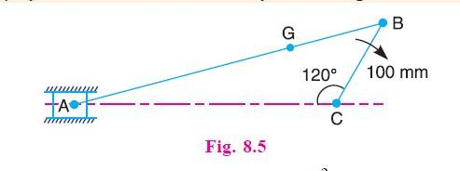  An engine mechanism is shown in Fig. 8.5. The crank CB = 100 mm and the connecting rod BA = 300 mm with centre of gravity G, 100 mm from B. In the position shown, the crankshaft has a speed of 75 rad/s and an angular acceleration of 1200 rad/s2. Find: 1. Velocity of G and angular velocity of AB, and 2. acceleration of G and angular acceleration of AB | 10M
7. |  |  |  | Locate all the instantaneous centres of the slider crank mechanism as shown in Fig. 6.12. The lengths of crank OB and connecting rod AB are 100 mm and 400 mm respectively. If the crank rotates clockwise with an angular velocity of 10 rad/s, find: 1. Velocity of the slider A, and 2. Angular velocity of the connecting rod AB.  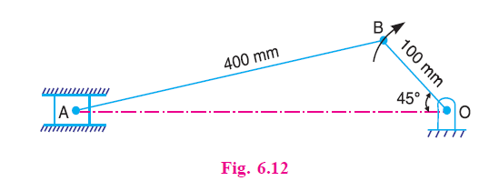 | 10M
8. | a. |  |  | What do you understand by the instantaneous centre of rotation in kinematic of machines? Answer briefly. | 5M
 | b. |  |  | Explain the following terms: (a) Instantaneous center (b) Body center and space centrode (c) Axode | 5M
9. |  |  |  | Explain with sketch the instantaneous centre method for determination of velocities of links and mechanisms | 10M
10. | a. |  |  | Discuss the three types of instantaneous centres for a mechanism | 6M
 | b. |  |  | Write the relation between the number of instantaneous centres and the number of links in a mechanism. | 4M
UNIT - IV
1. |  |  | A cam is to give the following motion to a knife-edged follower :  1. Outstroke during 60° of cam rotation ;  2. Dwell for the next 30° of cam rotation ;  3. Return stroke during next 60° of cam rotation, and 4. Dwell for the remaining 210° of cam rotation.  The stroke of the follower is 40 mm and the minimum radius of the cam is 50 mm. The follower moves with uniform velocity during both the outstroke and return strokes. Draw the profile of the cam when (a) the axis of the follower passes through the axis of the cam shaft, and  (b) the axis of the follower is offset by 20 mm from the axis of the cam shaft. |  |  | 10M
2. |  |  | A cam is to give the following motion to a knife-edged follower :  1. Outstroke during 60° of cam rotation;  2. Dwell for the next 30° of cam rotation;  3. Return stroke during next 60° of cam rotation, and  4. Dwell for the remaining 210° of cam rotation.  The stroke of the follower is 40 mm and the minimum radius of the cam is 50 mm. The follower moves with uniform velocity during both the outstroke and return strokes. Draw the profile of the cam when the axis of the follower is offset by 20 mm from the axis of the cam shaft. |  |  | 10M
3 |  |  | A cam drives a flat reciprocating follower in the following manner: During first 120° rotation of the cam, follower moves outwards through a distance of 20 mm with simple harmonic motion. The follower dwells during next 30° of cam rotation. During next 120° of cam rotation, the follower moves inwards with simple harmonic motion. The follower dwells for the next 90° of cam rotation. The minimum radius of the cam is 25 mm. Draw the profile of the cam. |  |  | 10M
4. |  | a. | Explain with sketches the different types of followers. |  |  | 5M
 |  | b. | Write short notes on cams |  |  | 5M
5. |  |  | What are the different types of motion and how the follower can move in it? |  |  | 10M
6. |  | a. | Draw the displacement, velocity and acceleration diagrams for a follower when it moves with simple harmonic motion. |  |  | 5M
 |  | b. | Draw the displacement, velocity and acceleration diagrams for a follower when it moves with uniform Acceleration and retardation. |  |  | 5M
7. |  |  | Design a cam for operating the exhaust valve of an oil engine. It is required to give equal uniform acceleration and retardation during opening and closing of the valve each of which corresponds to 60° of cam rotation. The valve must remain in the fully open position for 20° of cam rotation. The lift of the valve is 37.5 mm and the least radius of the cam is 40 mm. The follower is provided with a roller of radius 20 mm and its line of stroke passes through the axis of the cam. |  |  | 10M
8. |  |  | A cam rotating clockwise at a uniform speed of 1000 r.p.m. is required to give a roller follower the motion defined below :  1. Follower to move outwards through 50 mm during 120° of cam rotation,  2. Follower to dwell for next 60° of cam rotation,  3. Follower to return to its starting position during next 90° of cam rotation,  4. Follower to dwell for the rest of the cam rotation.  The minimum radius of the cam is 50 mm and the diameter of roller is 10 mm. The line of stroke of the follower is off-set by 20 mm from the axis of the cam shaft. If the displacement of the follower takes place with uniform and equal acceleration and retardation on both the outward and return strokes, draw profile of the cam and find the maximum velocity and acceleration during out stroke and return stroke. |  |  | 10M
9. |  |  | Define the following terms  - Cam  - Follower  - Offset follower  - Radial follower  - Mushroom follower |  |  | 10M
10. |  |  | It is required to set out the profile of a cam to give the following motion to the reciprocating follower with a flat mushroom contact face :  (i) Follower to have a stroke of 20 mm during 120° of cam rotation  (ii) Follower to dwell for 30° of cam rotation ;  (iii) Follower to return to its initial position during 120° of cam rotation ; and  (iv) Follower to dwell for remaining 90° of cam rotation.  The minimum radius of the cam is 25 mm. The out stroke of the follower is performed with simple harmonic motion and the return stroke with equal uniform acceleration and retardation. |  |  | 10M

UNIT – V
1. | a. | Explain the terms :(i) Module, (ii) Pressure angle, and (iii) Addendum. | 5M
 | b. | State and prove the law of gearing. Show that involute profile satisfies the conditions for correct gearing. | 5M
2. | a. | What do you understand by the term ‘interference’ as applied to gears? | 5M
 | b. | Write advantages and disadvantages of gears | 5M
3. |  | Explain the classification of gears with neat sketches | 10M
4. |  | Explain the epicycloid and hypocycloidal forms of teeth with neat sketch | 10M
5. |  | The number of teeth on each of the two equal spur gears in mesh are 40. The teeth have 20° involute profile and the module is 6 mm. If the arc of contact is 1.75 times the circular pitch, find the addendum. | 10M
6. |  | 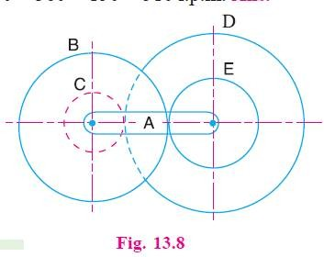  In a reverted epicyclic gear train, the arm A carries two gears B and C and a compound gear D - E. The gear B meshes with gear E and the gear C meshes with gear D. The number of teeth on gears B, C and D are 75, 30 and 90 respectively. Find the speed and direction of gear C when gear B is fixed and the arm A makes 100 r.p.m. clockwise. | 10M
7. |  | An epicyclic gear consists of three gears A, B and C as shown in Fig. 13.10.The gear A has 72 internal teeth and gear C has 32 external teeth. The gear B meshes with both A and C and is carried on an arm EF which rotates about the center of A at 18 r.p.m.. If the gear A is fixed, determine the speed of gears B and C  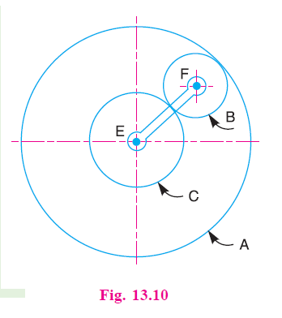 | 10M
8. |  | In an epicyclic gear train, an arm carries two gears A and B having 36 and 45 teeth respectively. If the arm rotates at 150 r.p.m. In the anticlockwise direction about the center of the gear A which is fixed, determine the speed of gear B. If the gear A instead of being fixed, makes 300 r.p.m. in the clockwise direction, what will be the speed of gear B?  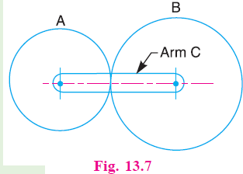 | 10M
9. | a. | What do you understand by ‘gear train’? Discuss the various types of gear trains. | 5M
 | b. | How the velocity ratio of epicyclic gear train is obtained by tabular method? | 5M
10. |  | Explain briefly the differences between simple, compound, and epicyclic gear trains. What are the special advantages of epicyclic gear trains? | 10M

